TEACHABLE MACHINE
Title: Machine Learning Model predicting the output for the given user input
Use the link below: https://teachablemachine.withgoogle.com/
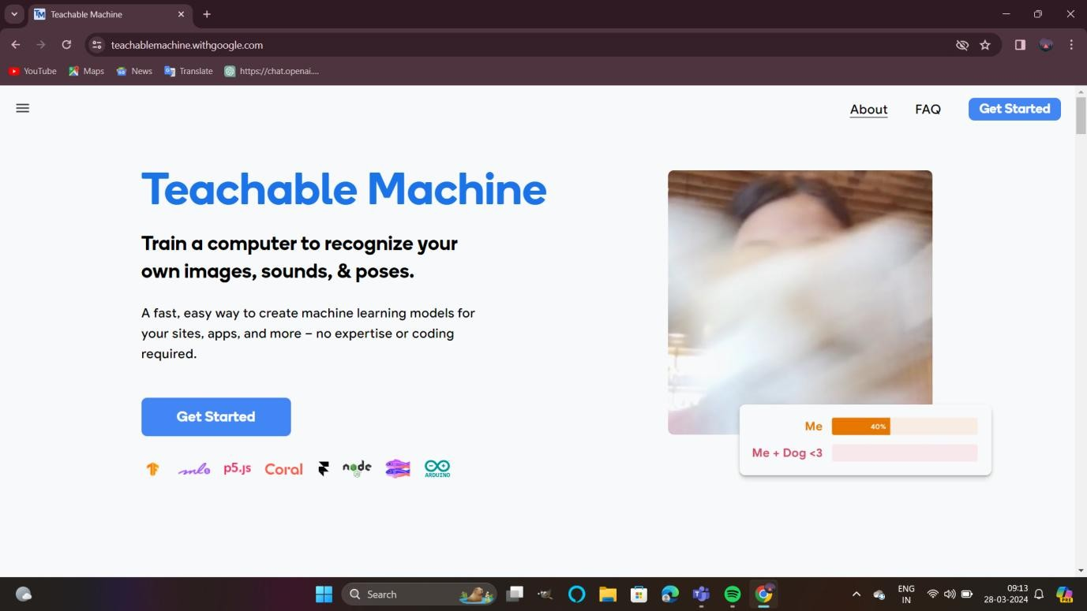
Click on get started
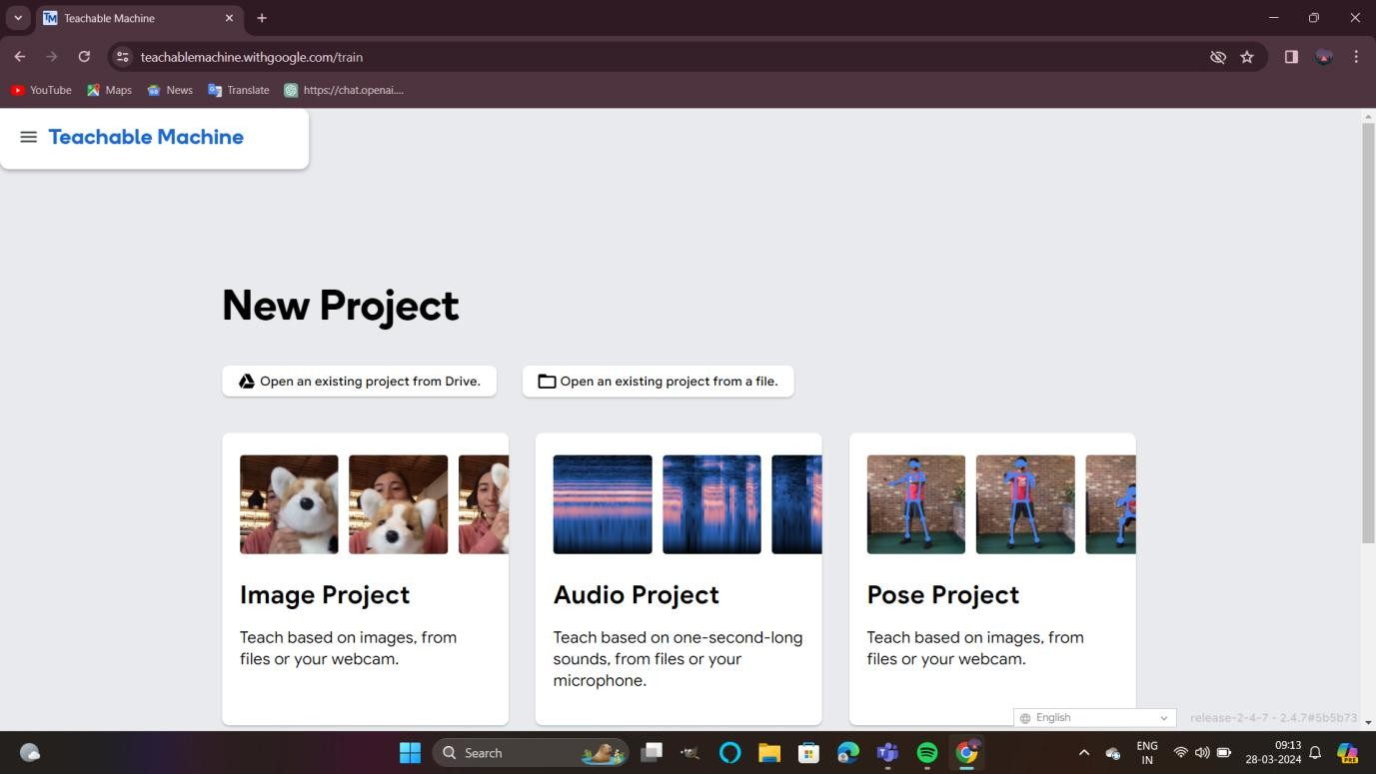
You can create projects and can play with these models
1. Image Project model:
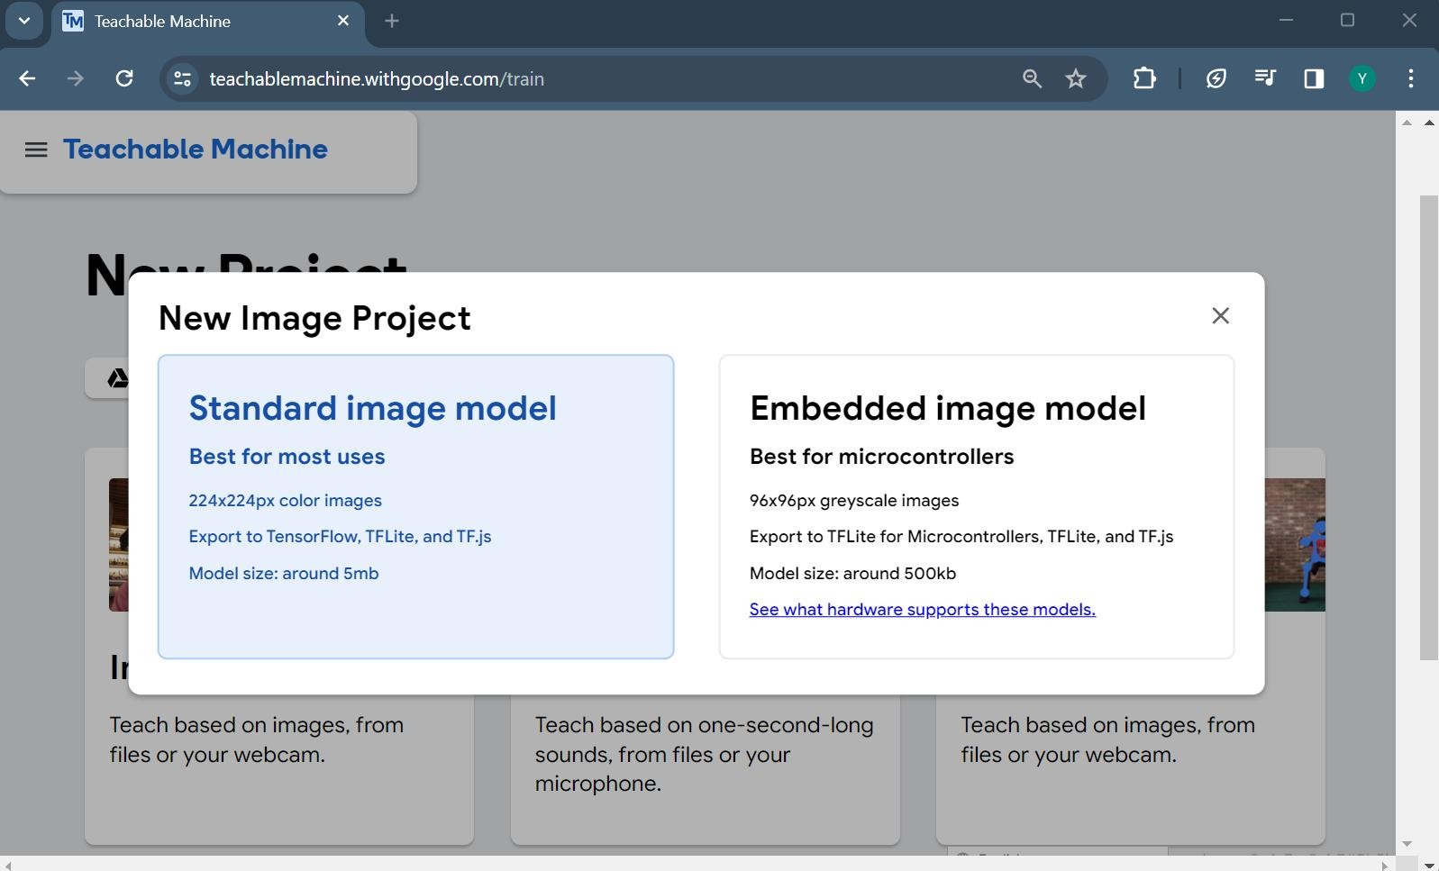
Choose Standard image model Project option
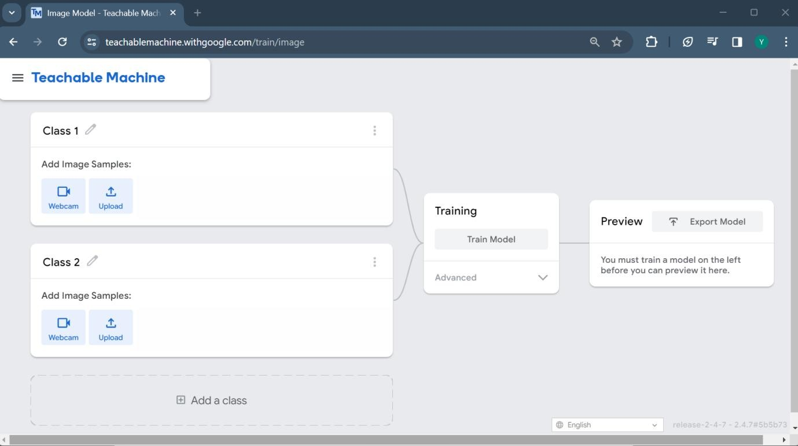
Now, create Machine learning model of two classes namely Class1: Harry Class2: Ron and Class3: Hermoinee respectively (can create more classes, depends on your purpose)
Now, create Machine learning model of two classes namely Class1: A Class2: B and
Class3: C respectively (can create more classes, depends on your purpose)
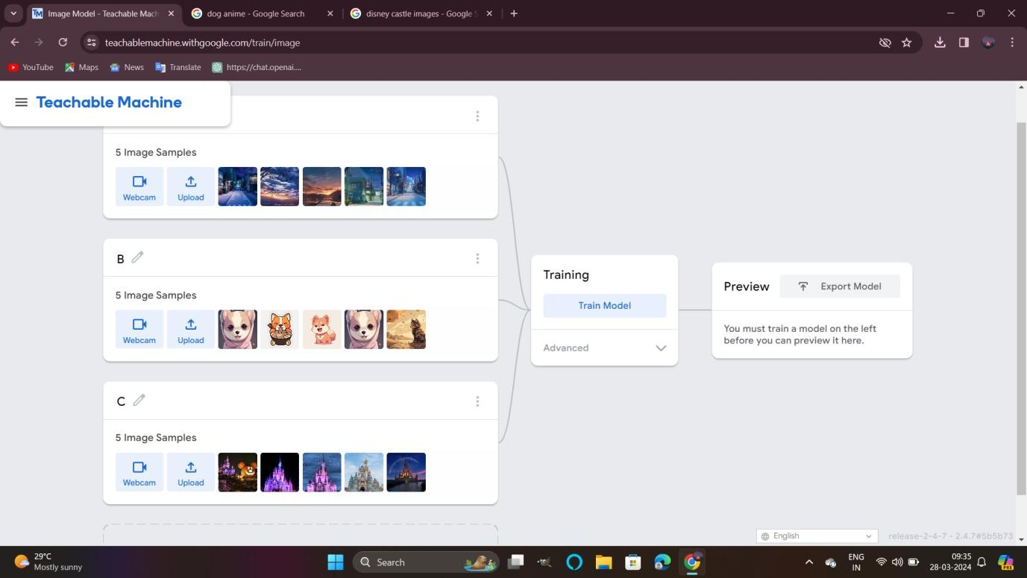

Upload sample images of A,Band Cand click on Train model finally, to train the model

Now, upload a new input (data point) in the preview panel box, it will predict the output.
